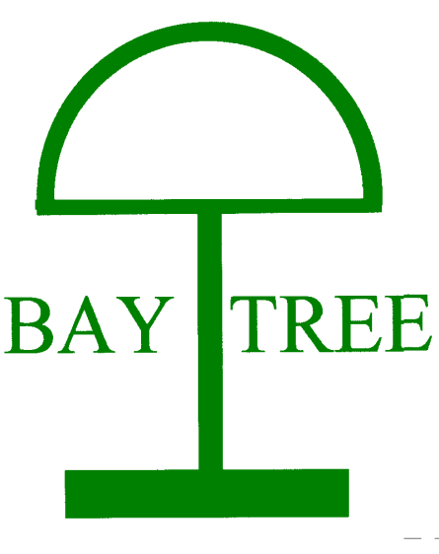
Baytree School
Measuring Impact

‘Making the most of every day’

At Baytree School the intent is to deliver a tailored and personalised curriculum which is motivating, challenging and ensures all learners are developing the next steps in their learning in the key areas that really matter to their development by equipping the learner with the skills needed for their next destination.
The assessment systems compliment the formal and holistic curriculum offer available to the learners at Baytree School ensuring all remain on track to achieve or exceed their annual medium term outcomes as well as the long term aspirational outcomes.
Assessing progress
In the immediate
At Baytree School we consider assessing progress a celebration of our learner’s accomplishments. All classrooms have a ‘Wow board’ where our learner’s immediate achievements and accomplishments in developing their communication and independence skills are celebrated.
We consider communication and independence our ‘Golden Threads’ that run throughout the entirety of our curriculum as developing these skills will ensure our learners are equipped with the skills they need for their next step beyond Baytree school.
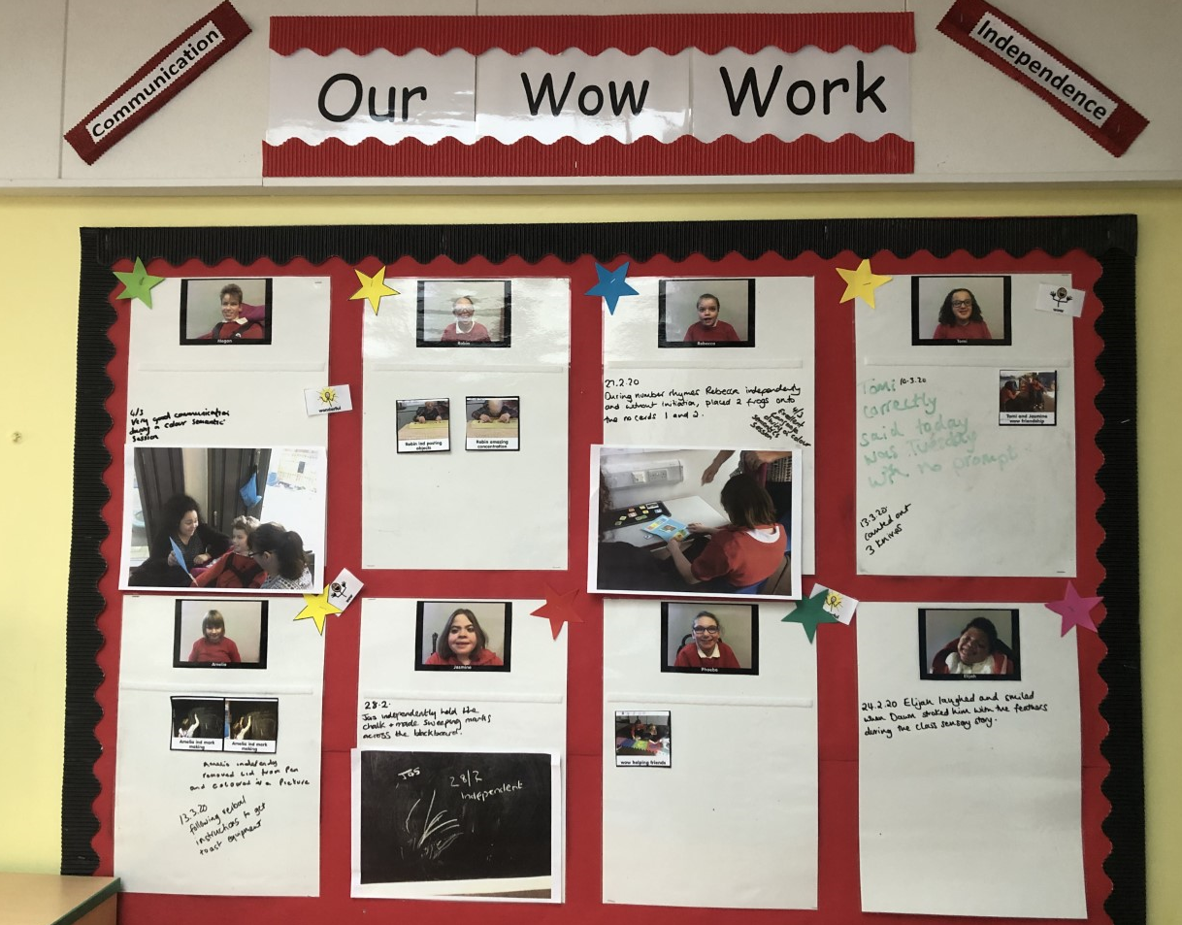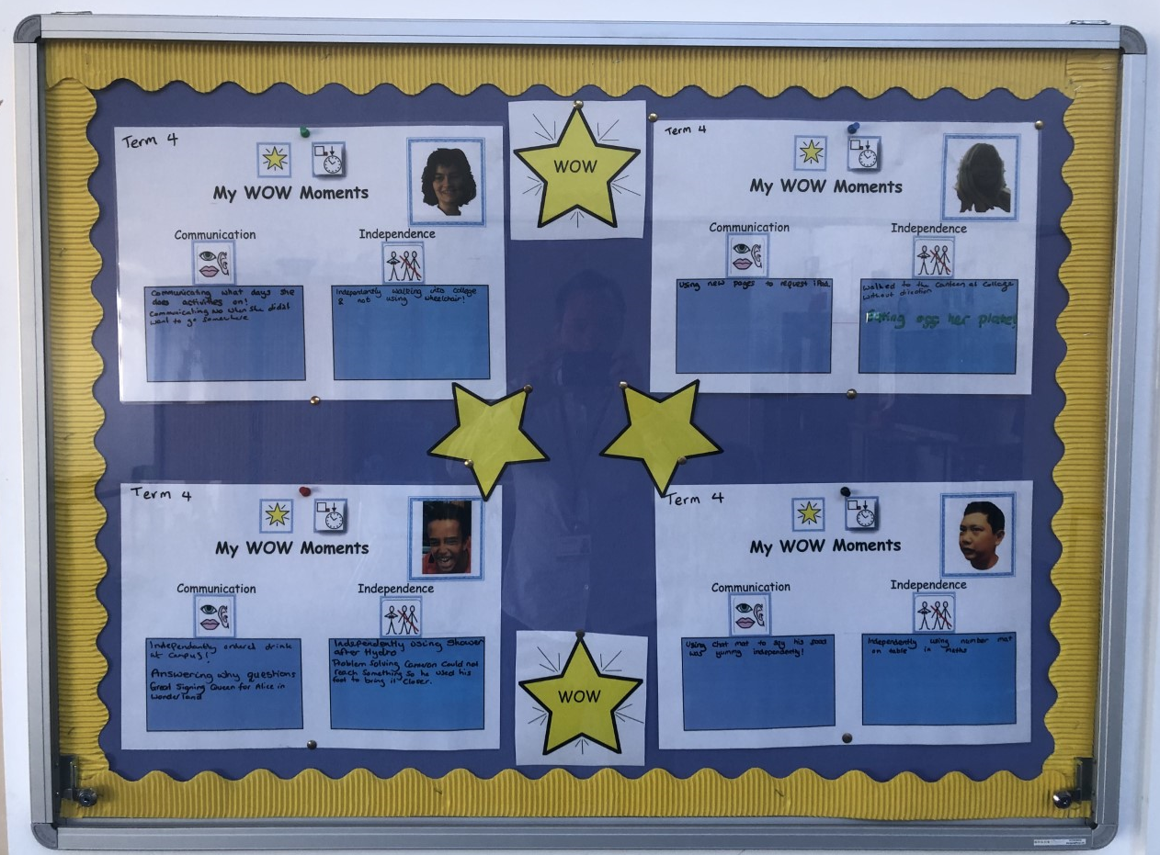
*Examples of ‘Wow Boards’ across the school.

Good Book assemblies
A weekly ‘Good Book’ Assembly is held to celebrate our learner’s achievements and successes across the course of the week. Teachers will identify individual learners and a certificate and acknowledgment is received during the assembly.
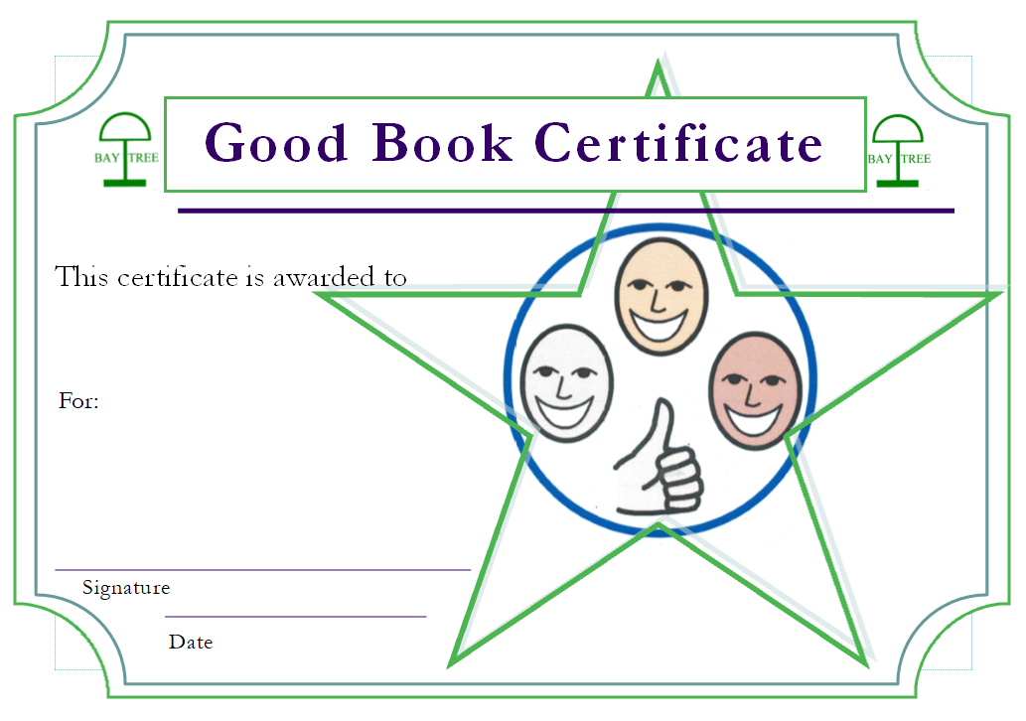
Annual Reviews and EHCP Outcomes
Within learners Educational Health Care Plans are detailed aspirational Long term and SMART Medium Term outcomes under each of the headings, Learning / Communication / Independence / Physical / Social, Emotional and Mental Health. Long term aspirational outcomes are expected to be met within 2/3 years whilst SMART Medium term outcomes in a year.
These outcomes are developed, reviewed and evaluated as part of the annual review process and as part of a multidisciplinary approach in co-production with parents. This ensures the outcomes are appropriate and challenging.
Target setting
Termly targets are set directly linking to the medium and long term outcomes that are identified through the annual process whilst linking with the Baytree School curriculum offer.
EHCP Headings | Termly Target
Learning | Learning Target 1- Reading Focus  Learning Target 2- Writing Focus (Subject Specific Learners only)  Learning Target 3- Number Focus
Communication | Communication Target 1- Expressive Focus  Communication Target 2- Receptive Focus
Physical | Physical Target 1- Gross Motor Skills  Physical Target 2- Fine Motor Skills (Sensory Learners only)
Independence | Independence Target
Social, Emotional Mental Health | Social, Emotional Mental Health Target

Trajectory of Learning
The diagram below shows how the termly targets link directly to the medium term and long term outcomes which show the learning trajectory each learner is on; this ensures all have an awareness of every learner’s next step on their learning journeys.
Example of an Independence Target and Outcomes
In 3 years, Pupil A will feed themselves independently.
In 1 year, Pupil A will take a spoon to their mouth independently.
By the end of term 1, Pupil A will explore a range of food textures.

The termly targets are collated and sent home to parents to provide families an opportunity to continue learning within the home environment. Class teams complete ongoing running records to record progress against each of the termly targets and identify next steps in learning. These records are systematically moderated by SLT / Class teachers in line with the Raising Achievement Plan (RAP). Once the term is completed, class teachers evaluate each termly target using a RAG rating system, this informs the following terms targets and demonstrates progress towards the medium term outcomes.
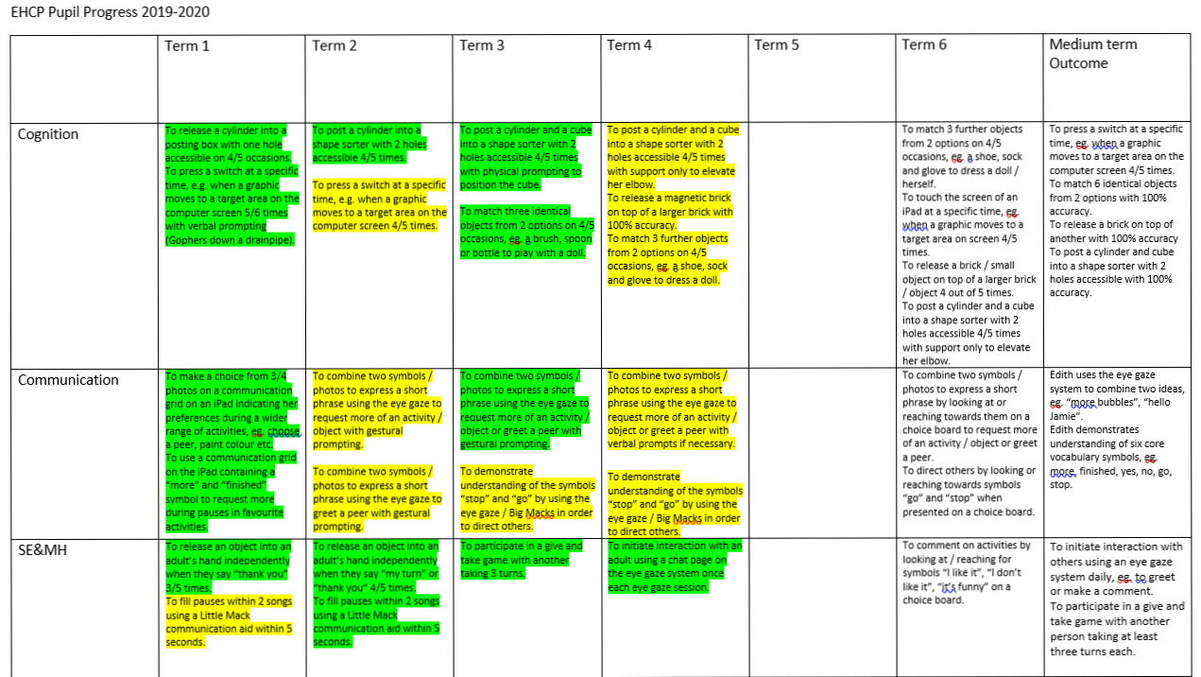
Evidence of progress
Alongside the daily running records, evidence of learning and progress is captured utilising pupil evidence sheets for our subject specific learners and the engagement scales for our sensory learners.
Subject Specific Learners - a pupil evidence sheet is completed within week 1 and week 6 (or as close to depending on term dates) to evidence the progress the learner has made against their termly target.
Sensory Learners - a teacher judgement will be made at the end of each term, class teachers will RAG rate the termly target and using this information make a judgement utilising the engagement scales of the learner’s progress towards their associated Medium Term Outcome.
Identification of next steps
To aid with identifying next steps, target setting and to ensure learners acquire the key skills and knowledge in a sequential manner, EHCP leads and subject leaders have developed progression documents which detail the sequential development of the skills and subject knowledge of their curriculum area acting as guides for class teachers to support in the identification of next steps whilst reflecting on the learning previously achieved.
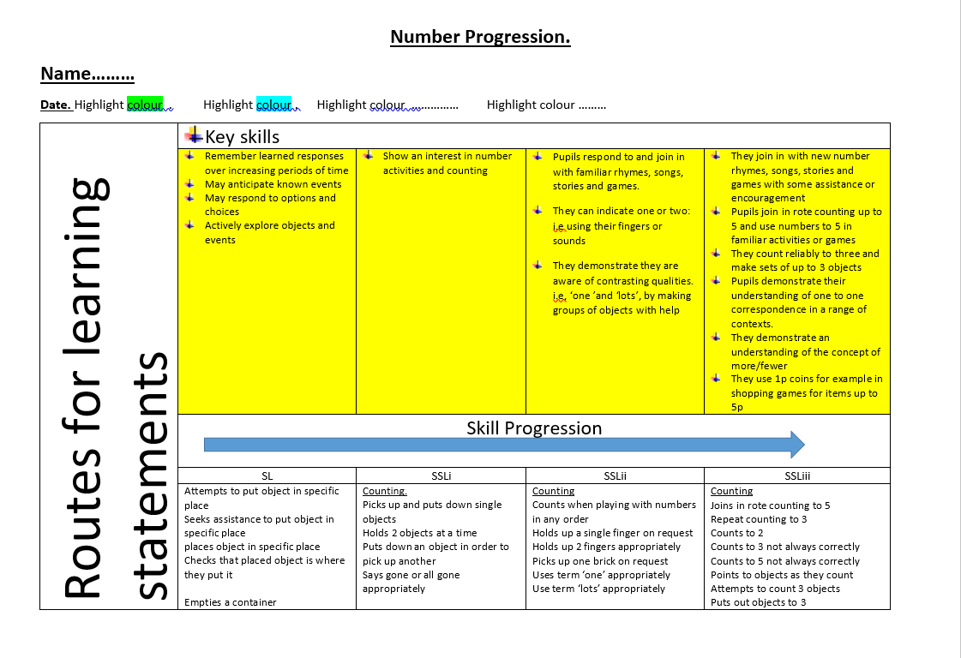
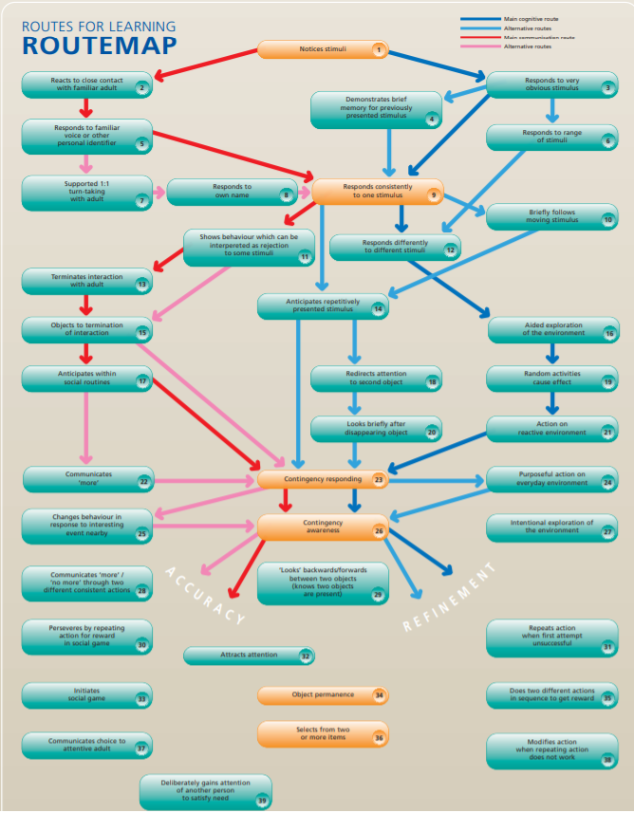
Routes for learning has been utilised to support teachers in identifying the next steps of learning for our sensory learners.

MAPP Assessments
Learners progress against their agreed Medium Term Outcomes are measured using a tool called MAPP. Teachers carry out this assessment x2 a year to measure progress to ensure learners are on track to achieve by their next annual review. Teachers assess the medium term outcomes against 4 key areas within MAPP- Independence / Fluency / Maintenance / Generalisation.
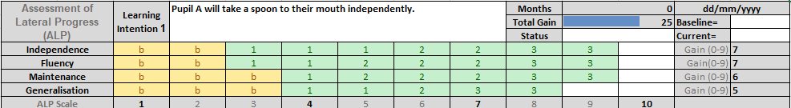
As the medium term outcomes are developed to be completed in a year therefore expected progress in each area (Independence / Fluency / Maintenance / Generalisation) will be 8-10 steps of progress.
MAPP progress is shared and celebrated with parents during parent’s evenings and at the annual review. The medium term outcomes are RAG rated and evaluated in the teacher’s annual review report which is subsequently shared with the local authority which ensures the learners EHCP remains current and up to date.
Triangulating pupil progress
MAPP baseline completed (end of term 1) MAPP assessments completed x2 annually (end of term 3 / 6)
Pupil progress meetings are held after each MAPP assessment and provide an opportunity to discuss off track pupils and identify interventions including deployment of the intervention assistant.
Systematic Monitoring and moderation of pupil progress completed by all inc governors in line with the RAP.
Pupil Progress Meetings
Pupil progress meetings occur after each MAPP assessment between each class teacher and the Headteacher. Each individual pupil and their progress against their individualised medium term outcomes are discussed. Class teachers provide the running records evidence, MAPP assessments and a judgement of whether the learner is off / on track / exceeding their MTOs. Where an individual appears off track interventions are identified including deployment of the intervention assistant for individual or small group sessions.
Ongoing pupil progress cycle

Internal and External moderation
To ensure our learners are continued to be challenged with aspirational outcomes an internal monitoring of a sample of learners termly targets and running records by SLT and class teachers takes place in line with the RAP.
External moderation is planned with a group of special schools across different local authorities. The external moderation identifies best practice and areas of development which is feedback to the appropriate class teacher.
Reporting Progress
After each round of MAPP assessments a pupil progress report is compiled by the Headteacher. This report highlights progress of all learners in each EHCP curriculum area as well as focussing on learners by key stage, pupil premium, gender and LAC. The pupil progress report is presented to the Governing Board for scrutiny. The pupil progress reports are also shared with EHCP and subject leaders to ensure they have the overview of learner’s progress within the EHCP / subject area they lead including learners who are identified as off track so they can provide the necessary support to class teachers. The pupil progress report also supports leaders with identifying key areas of strength and areas of development which informs the leader’s action plans.
EHCP Leaders
EHCP Leads create an annual action plan, which will identify key areas of development within their EHCP area of responsibility.
EHCP leads will play an influential role in monitoring progress, ensuring high expectations, delivering training, leading on initiatives and supporting colleagues.
EHCP Leads continue to have a curriculum responsibility, as this will ensure the curriculum remains current and up to date.
EHCP Area | Learning | Communication | Independence | Social Emotional Mental Health | Physical
Curriculum responsibility | Maths  English Reading / Writing | Expressive and Receptive | PSHE – incl. RSHE |  | Physical Development

Subject Leaders
Subject leaders lead the foundation subjects to ensure the curriculum remains broad and balanced. Subject leaders create annual action plans to ensure the curriculum remains current and up to date.
ICT / e-safety | RE / SMSC | Topic incl. Humanities, Art and DT | Music and the performing arts

Curriculum Teams
EHCP Leads and Subject Leads work within curriculum teams to ensure the curriculum areas complement one another.
The curriculum teams are overseen and supported by the Department Leads who provide support for progress against action plans and with the identification of next steps.
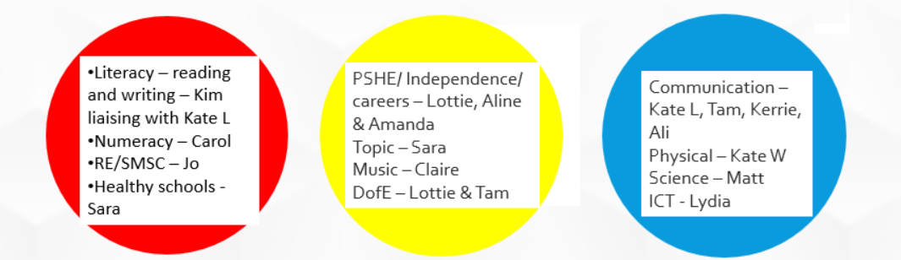
Governor responsibilities
The EHCP Leads have a link Governor who will support and challenge the leader to ensure the objectives within the action plan are met and are having the desired impact on our learners. Governors will feedback progress within the Governor Effectiveness meetings.
Early Years Assessment
Early years learners EHCP outcomes will not be assessed against MAPP however learners are assessed x3 yearly against the Early Learning Goals using the Baytree School adapted DEYO (Differentiated Early Years Outcomes) document. (https://www.bristol.gov.uk/documents/1199298/1225907/Differentiated+Early+Years+Outcomes/46f5b789-a09b-4476-80bd-fa7e9f9e9600)
This provides clear evidence of the learning and progress each young person has made during their nursery and reception years. Progress and achievements are recorded within the learner’s individual learning journals. This information helps to form the Long term and Medium Outcomes within the individual EHCP’s which are then to be tracked on entry into KS1.
KS4 and Post 16 Assessment
Duke of Edinburgh Award
Learners in key stage 4 work towards their Bronze Duke of Edinburgh award. Over the course of two years they complete modules relating to volunteering, physical and skills sections as well as an expedition. Activities within each section are implemented and incorporated within the individual learners tailored curriculum; this ensures the modules are relevant and meaningful for the learner and their next steps. The award enables learners to develop their practical skills and have new experiences. Achievements and progress in each section is recorded by the session leader and the successes of the learners are celebrated.
Accreditation
Post 16 learners achieve awards from the AQA unit award scheme. Units are personalised to each learner and are linked to learners EHCP outcomes or to specific skills relevant to a curriculum area and their next steps of learning. Learners complete a progressive programme of awards in a variety of curriculum areas to develop skills, independence levels and to transfer skills in order to prepare our learners for life beyond Baytree School.
Both key stage 4 and post 16 learners’ EHCP outcomes continue to be assessed and tracked against MAPP and the engagement scales to ensure our young people leave Baytree School with clear, relevant and meaningful aspirations that can be continued and supported by the relevant College, work placement / apprenticeships and/or support package. This ensures learners remain on their chosen pathway.
Destinations
Learners in post 16 can attend the link course at Weston College for one day a week; this supports our learners understand what a college course would be like, alongside starting to prepare them for a college setting. Regular meetings are held between Baytree School and Weston College staff to determine how the learner is progressing and determine their next steps on the link course.
We recognise that Weston College is not always the appropriate next setting for our learners beyond Baytree School and through partnership working with the young person, family and multi-agencies including the transition team the most appropriate provision is identified. Our learner’s final year at Baytree School will have a focused curriculum on preparing the learner for their identified next step. This may include a travel training programme, accessing the local community, work placements, developing independent living skills etc. In recent previous years, our learners have successfully transitioned to a range of different settings, such as local colleges, residential colleges and supported living services.
